Cryptography and The RSA Algorithm

Chris Campbell
EE 740

Abstract – This paper will explore several different methods of cryptography. Additionally, it will explain the basic function of these methods along with some different purposes these forms of Cryptography serve. Following research into different cryptographic algorithms, we will look to develop and deploy a python script with the help of ChatGPT. This script will be used to generate a public/private key pair using the RSA (Rivest-Shamir-Aldeman) algorithm. Next, the public/private key pair will be used to encrypt and decrypt a secret message containing the coordinates of a maritime ship. This will serve as an example of how this encryption method can be used by organizations such as the Navy to encrypt ship location data. This will obfuscate the data transiting from the ship back to headquarters without worrying about enemy interception.

Introduction
As the digital age continues to evolve and revolutionize society, it is of the utmost importance that we move the conceptual methods of security utilized in the real world into our digital environments. In the digital world, this is largely accomplished through cryptography. As described by IBM [1], cryptography is the practice of developing and utilizing code-based algorithms to protect and obscure transmitted information. This ensures that unauthorized parties are unable to access the transmitted information.
IBM [1] goes onto share that the word ‘Cryptography’ is derived from the Greek word ‘Kryptos’ meaning hidden. So, the literal translation of cryptography is ‘hidden writing’. Cryptography can be used to obscure any form of digital communication including text, images, video, and audio. This is accomplished by transforming data into an unreadable format known as ciphertext. This ciphertext can then only be decrypted into a readable format, known as plaintext, by use of some form of decryption method (which varies based on the algorithm used).
This paper will explore several different forms of cryptography. From here, I will dial in specifically on a form of asymmetric encryption known as RSA (Rivest-Shamir-Aldeman). With the help of ChatGPT, I will develop a python script which has the capability to encrypt and decrypt plaintext. This plaintext will include ship coordinates relative to a maritime vessel. This example will detail how the algorithm can be used in the real world. Particularly, how a naval force could share the location of its vessels with one another without having to worry about the enemy intercepting the cipher text.

Hash Functions
As described by Upadhyay et al. [2] A hash function is a mathematical transformation that converts a binary string of bits of an arbitrary length into a string of fixed size known as a hash value. Cryptographic hash functions are uni-directional and therefore cannot be reverted into the original string. This makes hashing unique to other forms of cryptography. There are three primary features to hash functions: collision resistance, preimage resistance, and secondary preimage resistance.
Upadhyay et al. [2] breaks down a description of these three features. Collision resistance describes the low odds that you get the same hash value from two separate inputs. Preimage resistance refers to the inability to convert a hash back into its original message. Finally, the second preimage resistance is a reference to weak collision resistance. This feature ensures that there is a low possibility of two inputs creating the same output.
An example of the importance of these features can be found in the following example. Let’s say an attacker obtains access to a file of stored password hashes. It is important that the attacker is unable to reverse the hashes to see the plaintext of the passwords (preimage resistance). Additionally, it is important that the attacker is unable to easily repeat a hash value. For example, if the attacker has a rainbow table and sees a matching hash value, they could use that specific password to obtain access to an account. Even if the original password is different from the password used in the rainbow table. This would be the process known as collision (alongside weak password policy). This is why collision resistance and secondary preimage resistance are important.
Another important step in preventing weak hashes is the process of password salting. Nugroho et al. [3] discuss the importance of salting passwords. Hash values stored in a database are vulnerable to dictionary attacks which attempt to find matching hash values. To overcome this. A salting technique is utilized to add a random value to the end of a password input prior to hashing. This will provide an entirely different hash than an attacker could find in dictionary attack. Fig. 1 below is an example from Professor Messer’s CompTIA Security+ training on password hashing [4]. As shown, the associated hash for the password ‘dragon’ changes significantly with different added salt values. Even though the plaintext of the passwords themselves are relatively similar, the hashes vary wildly. This obfuscation is significant in thwarting potential attackers.
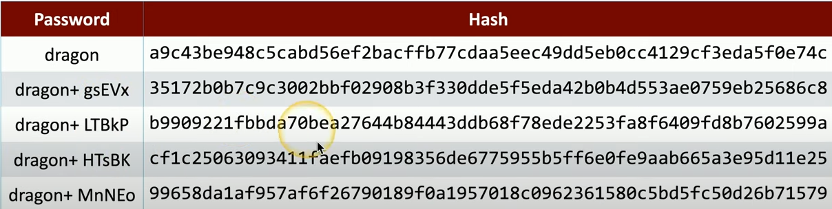
Fig. 1.

Symmetric/Asymmetric Algortihms
Two types of cryptography which are similar to one another are symmetric and Asymmetric cryptography. Both methods utilize keys for encryption and decryption. The primary difference however is that symmetric encryption utilizes a single private key, while asymmetric encryption uses a public/private key pair.
As described by Naufal et al. [5] Symmetric encryption algorithms use a single unique key for both encryption and decryption of data. Symmetric encryptions are shorter than most other forms of encryptions. For this reason, it is generally used more often for longer messages. The two methods of symmetric encryption are stream ciphers and block cyphers. As described by Professor Messer in CompTIA Security+ training Block vs. Stream Ciphers [7] block cyphers encrypt fixed-length groups of 64-bit or 128-bit blocks. Stream ciphers are the same as block ciphers, however they only encrypt small blocks one bit or one byte at a time.
Naufal et al. [5] additionally cover the basic definition of an asymmetric algorithm. They suggest that an asymmetric algorithm uses two keys defined as public and private. The public key which can be shared is utilized in the encryption process. Then the associated private key which is not shared can be used for decryption. Unlike its simpler symmetric counterpart, the asymmetric algorithm uses complex mathematical computation methods and is not as efficient. However, since asymmetric encryption is far better than symmetric encryption when it comes to security, asymmetric encryption is used for more important things like visiting websites (HTTPS) and bitcoin wallets.
One specific asymmetric algorithm which is widely used is the RSA algorithm. As described by Kadei et al. [8], the RSA encryption method was developed by three professors at MIT. The name RSA comes from the last names of these professors; Ron Rivest, Adi Shamir, and Len Adleman. They go on to discuss how this specific algorithm works. The initial stage of this this technique is to generate the keys. Generated keys use the standard RSA with 1024 bits. Since communication is bidirectional, public and private keys are generated for sender and receiver. RSA keys are imported in xml files to serve the user.
Kadei et al [8] share in Fig. 2 below how the math is done for generation of the public key. To begin, two initial prime numbers need to be selected represented as ‘p’ and ‘q’. Additionally, a value for ‘e’ has to be selected. The value for ‘e’ must be a prime number and needs to be greater than 1. From here, the below computation takes place.
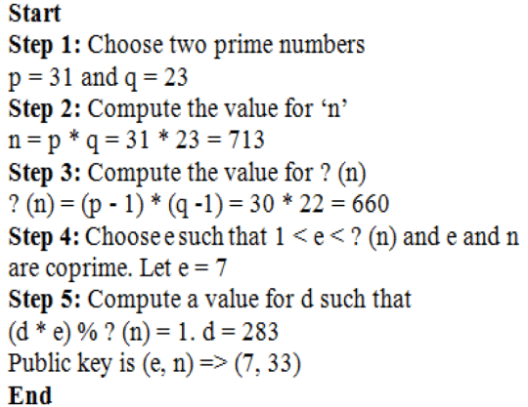
Fig 2.
As show below, the public key is represented by ‘(e,n)’ which equates above to ‘(7, 33)’. The private key is represented by ‘d’ which equates to ‘283’ above.

Developing an rsa algorithm

Particularly as it pertains to military maritime activity, it is incredibly important to keep the locations of our country’s marine vessels confidential. As a former sailor onboard the aircraft carrier USS Dwight D. Eisenhower, I am fully aware of how important our secrecy was. Aircraft carriers are the flagships of naval battle groups and generally carry 5,000 to 8,000 sailors at any given time. With these numbers, it’s very hard to keep their locations secret, since almost everyone onboard becomes a threat to that secrecy. While deployed, we had briefings regularly about how people were not supposed to post pictures or messages to the internet while in port or (more importantly) at sea to ensure the ships locations remained hidden from the enemy.
While ensuring the confidentiality of an aircraft carrier’s location could be a challenge at times, it’s not the purpose of an aircraft carrier to be particularly stealthy with planes constantly flying back and forth from it. However, the location of our country’s submarines is top-secret. These vessels are located at tactical locations around the world with the ability to fire missiles, including nuclear warheads, at any time from undisclosed locations. It is easy to see why it is of the utmost importance to keep the location of these vessels shrouded in mystery. Nevertheless, our country still needs to communicate with these vessels and always know their locations.
Generally, the location of marine vessels is sent via Automatic Identification Systems (AIS) which are transmitted over radio waves. Computer models interpret these transmissions to associate different vessels between fishing and non-fishing vessels. Kurt Schwehr wrote a program that can interpret these messages as plaintext which shares important information about the ship’s location including things like longitude, latitude, date/time, heading, Marine Mobile Service Identities (MMSI), etc [9]. Albeit, military vessels only communicate with other ships via AIS when transiting through highly trafficked waters, they still need to return their coordinates back to Navy headquarters. This is generally done through encrypted satellite communications [10]. While AIS and satellite communications are different, the source coordinates are the same in plaintext.
Theoretically, using the RSA algorithm a marine vessel could encrypt its plaintext coordinates with the public key and send that message back home via satellite where these coordinates could only be decrypted using the private key. Now that we have a basic understanding of cryptography and some of the underlying algorithms, we will move onto the next portion of this project. We will be working with ChatGPT, a large language model-based AI, to develop an algorithm in python to model the RSA algorithm. Once produced, we will use the program to encrypt and decrypt an example of a ship’s coordinates.
To begin, the plaintext message we will be using is an old 2016 location of a marine vessel known as VALMITAO, callsign CUFN [9]. While this is a fishing vessel, we could imagine that military vessels would use these same types of coordinates in the same way. The location of this vessel is as follows:
- Class: AIS
- mmsi: 263576000
- timestamp: 2016-10-07 00:07:29 UTC
- longitude: 62.7572784424
- latitude: -26.3910827637
- speed: 1.5
- course: 296.0
- heading: 354
- sync_state: 3
- maneuver:0
These coordinates would put this vessel off the coast of Madagascar in the Indian Ocean as shown below [11]:
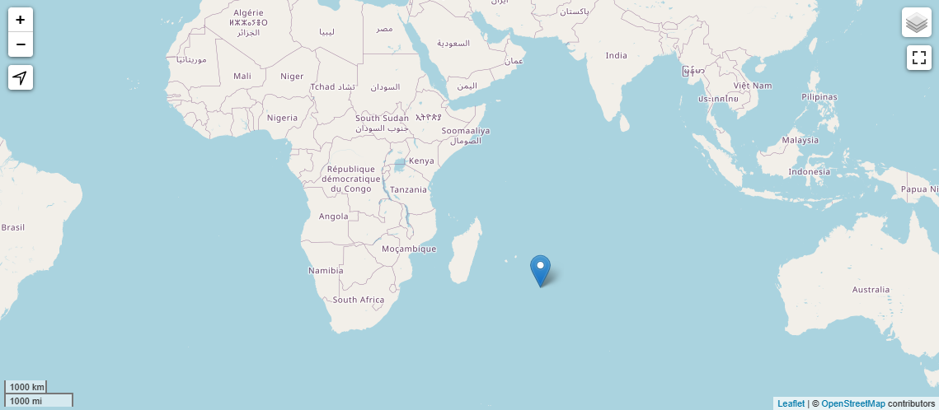
To begin the process, I started by prompting ChatGPT to write a python script to generate a public/private key pair using the RSA algorithm. From here I asked ChatGPT to include functions for encrypting and decrypting a plaintext file using the generated keys. The process from here took a little bit of troubleshooting to get everything functioning properly. While ChatGPT is truly an incredible resource, it is not without its problems.
One issue I ran into was when working with ChatGPT was when I was getting an error and its correction to that error was the exact same line of code reiterated. It was unable to see the mistake and was confident about the solution it presented. This did end up taking a bit of troubleshooting on my end, but we were able to resolve the issue. While ChatGPT could not resolve the issue itself in this instance, I was able to ask the LLM what possible remedies to the error could be. From that list it presented, I was able to dial in on the error and correct it.
After just a few hours of developing and troubleshooting with ChatGPT, we developed a program that would have otherwise taken me alone at least a week to research, troubleshoot, and execute a properly working program. This would have taken me so much time because we are working with the python ‘cryptography’ library. This is my first time using this library and it is an incredible tool. However, it uses a lot of library specific modules which are necessary to leverage the different ciphers available. ChatGPT was able to reference and precisely describe what all the different modules were for and how to use them.
Now, we will step through the code piece by piece, sharing what is going on in each step of the process. The following descriptions are generated with the assistance of ChatGPT for some of the more specific details relative to ‘cryptography’ modules.

Step 1. Importing modules
To begin, we imported the following into the program:
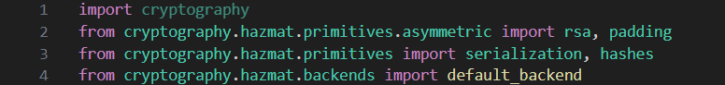
This first block of code shares all of the modules we are importing to the program to make all of its part function as required. This relies heavily on the ‘cryptography’ library.
- import cryptography
This imports the cryptography library to the program. Allowing for the utilization of all modules and submodules for this project.
- from cryptography.hazmat.primitives.asymmetric import rsa, padding
These modules provide functionality of working with RSA encryption and padding schema.
- from cryptography.hazmat.primitives import serialization, hashes
These modules provide functionality for serializing cryptographic objects and working with cryptographic hashes.
- from cryptography.hazmat.backends import default_backend
This module provides a default cryptographic backend implementation which is used by ‘cryptography’ library for performing cryptographic operations.

Step 2. Generating the RSA Keys
Moving on, the first function in this python script is ‘def generate_keys()’ which is used for the generation of the RSA keys. This function is written as follows:
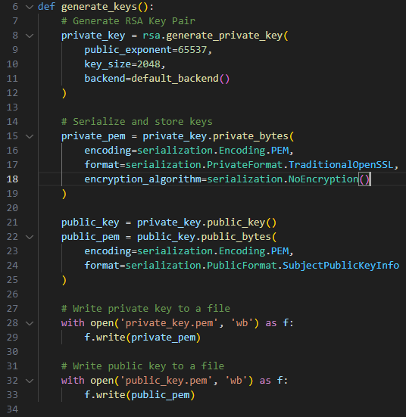
As shown, this section of code breaks down the function for generating RSA keys. Seperated by four comments; generating the keys, serializing and storing the keys, and writing the private and public keys to files individually. Obviously, line 6 defines the function ‘generate_keys(). The code within each comment can be broken down as follows:
- # Generate RSA Key Pair
This portion of the code generates the RSA private key with a public exponent of 65537 and a key size of 2048 bits using the ‘generate_key.private_bytes()’ function from the ‘rsa’ module.
A public exponent of 65537 and at least 2048 bits is a common choice and should always be used unless there is a specified reason to do otherwise [12].
- # Serialize and store keys
This portion serializes the private key into a PEM (Privacy Enhanced Mail) format using the ‘private_bytes’ method. This allows the keys to be saved as bytes in a file. Additionally, it specifies the encoding format, the private key format (traditional OpenSSL), and no encryption algorithm.
In addition, this portion of the code serializes the public key into a PEM format using the ‘public_bytes’ method. ‘SubjectPublicKEyInfo’ is used to specify the encoding format and public key format.
- # Write private key to a file
This portion writes the serialized private key to a file named ‘private_key.pem’ in binary mode indicated by ‘wb’.
- # Write public key to a file
This portion writes the serialized public key to a file named ‘public_key.pem’ in binary mode indicated by ‘wb’.

Step 3. Encrypting the plaintext
Following the generation of the keys, we move onto the next phase of this program which is setting up a function for file encryption. This will allow us to run a file through this function and produce an output file which is encrypted ciphertext. This function is written as follows:
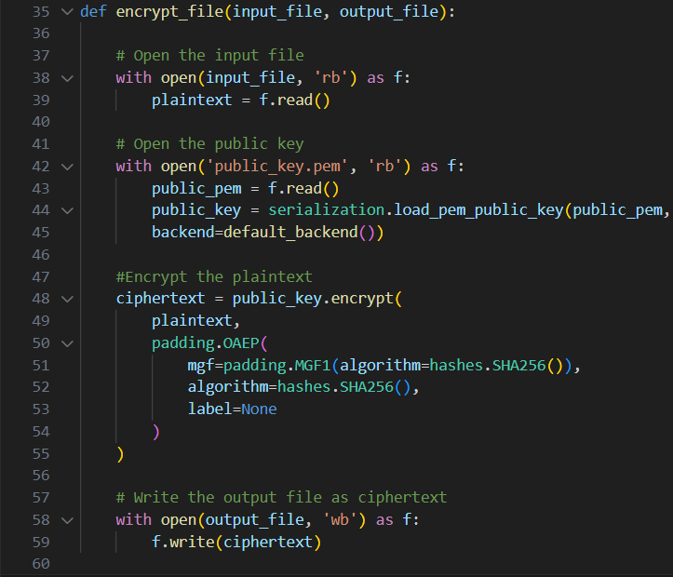 Below, we will break down what each of the four commented sections are performing with the help of ChatGPT.
- # Open the input file
This will open the input file, which is the plaintext file to be encrypted, in binary read mode (‘rb’). With is used to ensure the file is closed out properly and assigns the file object as ‘f’. File ‘f’ is then read. The serialization module here allows for deserialization of the key allowing it to be used in the program.
- # Open the public key
This will open the public key file in binary read mode (‘rb’). Again, the with statement allows proper closing of the file while assigning the file object as ‘f’. The file is then read and the ‘load_pem_public_key’ function from ‘serialization’ is used to deserialize the PEM-encoded public key data. ‘backend’ is used for key loading.
- #Encrypt the plaintext
This encrypts the plaintext using the public key. The encryption is used with Optimal Asymmetric Encryption Padding (OAEP), which is a padding scheme used in RSA encryption to add probabilistic encryption. This OAEP scheme with SHA256 as the mask generating function (MGF) and SHA256 as the hash algorithm. All of this is assigned to the variable ‘ciphertext’.
- # Write the output file as ciphertext
This section will write the ciphertext as an output file in binary (‘wb’).

Step 4. Decrypting the Ciphertext
Following encryption of the plaintext. We next go onto write a function to decrypt the ciphertext. Below we see the code utilized for this function:
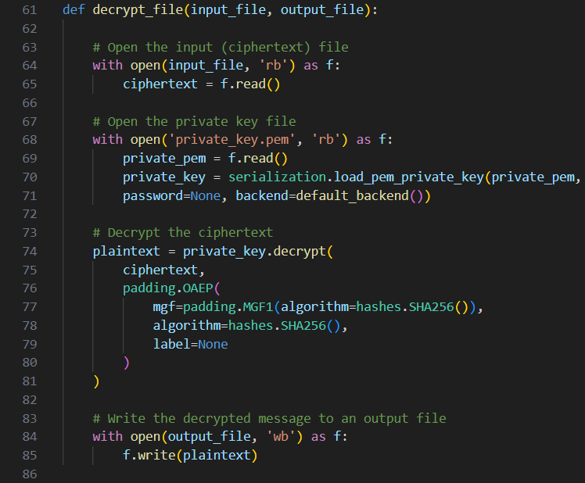
From here we will break down what each of the four commented sections are doing in support of decrypting the ciphertext..
- # Open the input (ciphertext) file
Here the input ciphertext file is read as a binary (‘rb’) into the function associated the file object as ‘f’ and then assign it to the variable‘ciphertext’
- # Open the private key file
This will open the private key file in binary read mode (‘rb’). As described in the encryption function, the with statement allows proper closing of the file while assigning the file object as ‘f’. The file is then read and ‘load_pem_private_key’ function from ‘serialization’ is used to deserialize the PEM-encoded private key data. ‘backend’ is used for key loading. The serialization function here allows for deserialization of the key allowing it to be used in the program.
- # Decrypt the ciphertext
This decrypts the ciphertext using the private key. The decryption is used with Optimal Asymmetric Encryption Padding (OAEP), which is a padding scheme used in RSA encryption/decryption to add probabilistic encryption/decryption. This OAEP scheme with SHA256 as the mask generating function (MGF) and SHA256 as the hash algorithm. All of this is assigned to the variable ‘plaintext’.
- # Write the decrypted message to an output file
This section will write the ciphertext as an output file in binary (‘wb’).

Step 5. Run the program and call the functions
Lastly, we call all three of the developed functions to generate the private and public keys, encrypt the plaintext secret message, and subsequently decrypt the ciphertext back into the original plaintext.
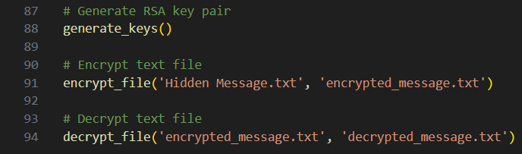
As shown above, ‘generate_keys()’ is called to generate the public and private key. ‘encrypt_file()’ takes an input file known as ‘Hidden Message.txt’ and writes the subsequent ciphertext to the associed file name ‘encrypted_message.txt’. Finally, ‘decrypt_file’ takes the input of the cipher text ‘encrypted_message.txt’ and writes the output file which is in the form of the original plaintext message ‘decrypted_message.txt’.
Next, we will run the program using Visual Studio Code (VSC) and show how this program operates as it encrypts and decrypts our ships coordinates.
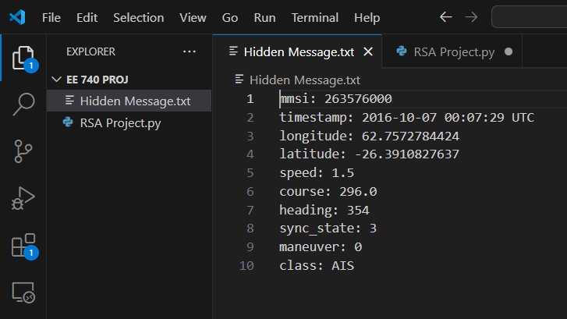
As we can see in the above photo, we start with only our ‘RSA Project.py’ program and our ‘Hidden Message.txt’ file. Additionally, we can see all of our plaintext inputs for our ships coordinates in the Indian Ocean. Once we run the program, we expect to see a public and private key pair generated, an encrypted ciphertext file, and a decrypted file of our original plaintext.
Once run, we can see all these anticipated files have been created in ‘EE740 PROJ’ folder. Below shows all of these new files generated in our folder:
Here is our generated public key which is used for encrypting the plaintext of any message desired. In our case, this public key is used for encrypting the ‘Hidden Message.txt’ to veil our ships coordinates as ciphertext before sending it out to headquarters.
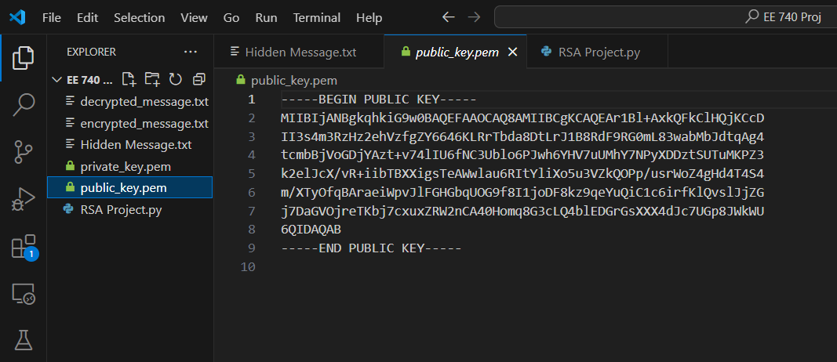

Here is our generated private key. This key is utilized for the decryption of the ciphertext ‘enrypted_message.txt’. This is the key which would be only shared to those who absolutely must have it. In our case, Navy headquarters would have this key in order to decrypt cipher text which was encrypted by the associated public key.
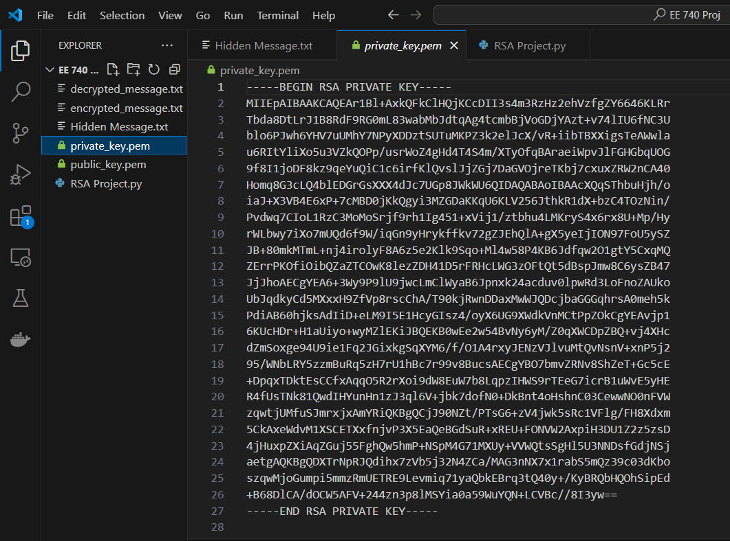

This is our encrypted ciphertext, encrypted by the public key. As we can see, it is completely illegible. It is a mixture of different letters, characters, numbers, and symbols. Shared here is both the encrypted message.txt file and the opened file in VSC. VSC doesn’t have the buit in capability to open this file. So trying to open it as a basic text file in VSC reders the ciphertext even less legible to the human eye.
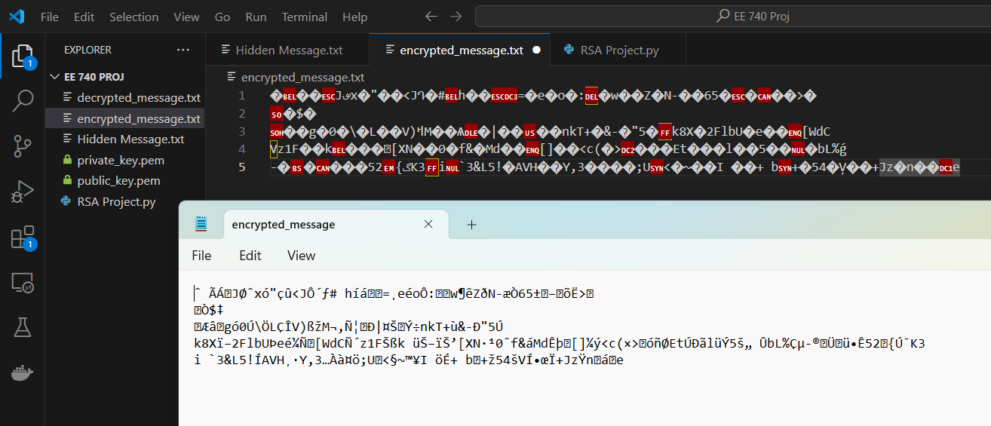

Finally, we have our final decrypted message which was decrypted by the public key. This file has all of our original coordinates. It shows the MMSI, timestamp, longitude, latitude, etc.
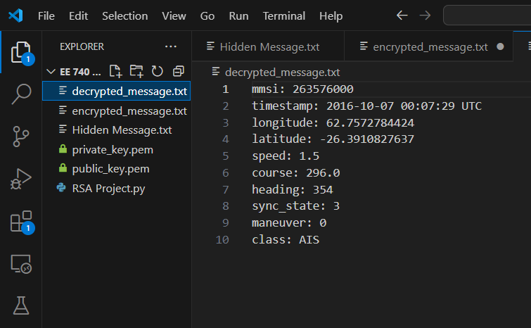

As expressed in this example, we have successfully created an RSA public/private key pair. This public/private key pair was then used to encrypt and decrypt the coordinates of our maritime ship operating in the Indian ocean off the coast of Madigascar. As we can see, this information here details everything anyone would want to know about a ships location. As it pertains to Naval operations, it is crucial to ensure that coordinates like these do not fall into the wrong hands. Algorithsm such as the RSA algortihm have the power to aid in this task.

Conclusion
In conclusion, cryptography is an incredibly important asset in the modern digital age. The ability to obfuscate digital data we do not want others to have access to is paramount in ensuring privacy and safety online. While there are several different cryptographic methods explained in this paper, we have spent most of our time, effort and energy here focusing on asymmetric encryption. Particularly, we have taken a deep dive into the RSA algorithm and have created a hands-on example of this specific type of algorithm with the help of ChatGPT. From this we explored how a Naval force could leverage this type of cryptography to obfuscate their coordinates and pass that data securely between the ships themselves and headquarters.

References

- What is cryptography?. IBM. (n.d.). https://www.ibm.com/topics/cryptography
- D. Upadhyay, N. Gaikwad, M. Zaman and S. Sampalli, "Investigating the Avalanche Effect of Various Cryptographically Secure Hash Functions and Hash-Based Applications," in IEEE Access, vol. 10, pp. 112472-112486, 2022, doi: 10.1109/ACCESS.2022.3215778.
- A. Nugroho and T. Mantoro, "Salt Hash Password Using MD5 Combination for Dictionary Attack Protection," 2023 6th International Conference of Computer and Informatics Engineering (IC2IE), Lombok, Indonesia, 2023, pp. 292-296, doi: 10.1109/IC2IE60547.2023.10331606. keywords: {Dictionaries;Passwords;Informatics;dictionary attack;md5;password hash;salt},
- Professor Messer, Hashing and Digital Signatures. Hashing and Digital Signatures - CompTIA Security+ SY0-701 - 1.4 (youtube.com)
- M. R. Naufal, C. A. Sari, E. H. Rachmawanto, L. B. Handoko, F. O. Isinkaye and W. S. T. Al-Dayyeni, "An Evaluation of Number of Pixels Change Rate (NPCR) in Symetric Cryptography Based on Data Encryption Standard (DES)," 2023 International Seminar on Application for Technology of Information and Communication (iSemantic), Semarang, Indonesia, 2023, pp. 490-495, doi: 10.1109/iSemantic59612.2023.10295300. keywords: {Seminars;Ciphers;PSNR;Image edge detection;Mean square error methods;Color;Encryption;Data Encryption Standard;PSNR;UACI NPCR},
- OpenAI. “ChatGPT: A large language model trained by OpenAI.” [Online]. Available: https://openai.com/chatgpt. [Accessed: February 11, 2024].
- Professor Messer, Block vs. Stream Ciphers. Block vs. Stream Ciphers - CompTIA Security+ SY0-401: 6.1 - Professor Messer IT Certification Training Courses
- F. H. M. S. Al-Kadei, H. A. Mardan and N. A. Minas, "Speed Up Image Encryption by Using RSA Algorithm," 2020 6th International Conference on Advanced Computing and Communication Systems (ICACCS), Coimbatore, India, 2020, pp. 1302-1307, doi: 10.1109/ICACCS48705.2020.9074430. keywords: {Encryption;Public key;Image resolution;Decoding;Communication systems;Image encryption;RSA;RSA speed up;Encryption and decryption algorithms;RSA speed up techniques},
- K. Cutlip, "What Does an AIS Message Look Like Anyway?" [Online]. Available: https://globalfishingwatch.org/data/what-does-an-ais-message-look-like-anyway/. [Accessed: 04/24/2024]
- Werner, B. (2017, September 19). Deadly Collisions Prompt Navy to Broadcast Warship Locations in High Traffic Areas. USNI News. Retrieved from https://news.usni.org/2017/09/19/deadly-collisions-navy-will-broadcast-warship-locations-high-traffic-areas
- "Coordinates converter | latitude longitude GPS coordinates," Maps.ie. [Online]. Available: https://www.maps.ie/coordinates.html. [Accessed: 04/24/2024]
- "Cryptography - RSA," Cryptography, [Online]. Available: https://cryptography.io/en/latest/hazmat/primitives/asymmetric/rsa/. [Accessed: 04/24/2024].

